# EXECUTIVE SUMMARY

Woolworths launched its first store in Sydney on December 5, 1924. The Woolworths Limited, with the WOW code, was registered on the Australian stock exchange in 1993. (Woolworths, 2007).Woolworths operates supermarkets, general retail, consumer electronics, wholesaling, and hotels, among other businesses. The 'Differentiation Strategic approach’ is Woolworths' company's current strategic approach..' In order to become the industry's class leader, this strategy urges the company to focus on establishing a highly distinctive product range and marketing campaign. The company’s differentiation strategic approach has worked because of their catchphrase, "Fresh Food People." By centering the business on the core value of "fresh" food, Woolworths got able to secure a large share from the market. "In this article, Woolworths was selected as a case research study to demonstrate the importance of concept of the supply chain management by adopting its Project Refresh strategic approach to improve financial performance and sustain a competitive advantage. In order to build effective and efficient supply chain management, Woolworths has examined best practices from large retailers such as Wal Mart and Tesco. The competitive strategic approach, synchronization, and risk evaluation of Woolworths' company supply chain will be examined in this article, as well as offer comments, performance analysis, and recommendations. The relevance of supply chain management in attaining a competitive advantage is demonstrated in a case study on Woolworths.Woolworths was chosen because, as part of an initiative named Project Refresh, it was able to produce great financial outcomes by restructuring its supply chain management. By better regulating its supply chain, Woolworths is able to save a large amount of money. Woolworths was the only Australian firm As a result of its performance, it was recognized in the  Research Study of AMR in Top twenty five  in 2005 and as well as next year..

|  |  |
| --- | --- |
| **TABLE OF CONTENTS** | |
| 1. **INTRODUCTION OF REPORT** | 06 |
| 1. **MANAGEMENT OF SUPPLY CHAIN** | 07 |
| * 1. Definitions | 07 |
| * + 1. Value Chain | 07 |
| 2. 1.2 The Supply chains | 07 |
| 2. 1.3 Direct chain of supply | 08 |
| 2.1.4 Extended chain of supply | 08 |
| 2.1. 5 Complex chain of supply | 08 |
| 2.2 Competitive Strategic approach | 09 |
| 2.3 The Woolworth’s Project Refresh | 09 |
| 1. **REDESIGNED SYSTEM OF WOOLWORTHS SUPPLY CHAIN.** | 10 |
| 3.1 Redesigned Functions And The Number Of Total Distributional Stores | 10 |
| 3.2 Transport Management System (TMS) | 11 |
| 3. 3 Informational Technology System for assisting efficiently their management of Supply Chain | 11 |
| 1. **WOOLWORTHS WAY OF ALIGNMENT OF SUPPLY CHAIN WITH BUSINESS STRATEGIC APPROACHES AND CUSTOMER REQUIREMENTS** | 14 |
| 4.1 Influence and Adaptive | 14 |
| 1. **SYNCHRONIZATIONAL IMPROVEMEMTS** | 15 |
| 1. **RISKS/DISADVANTAGES** | 16 |
| 6.1 Product And Its Risk in Service Management. | 16 |
| 6.2 Risks in Information Managements | 16 |
| 6.2.1 Revenue growth and comparison | 17 |
| 1. **RECCOMENDATIONS** | 18 |
| 1. **THE CONCLUSION OF CASE STUDY** | 20 |
| 1. **REFERENCES OF THE REPORT** | 21 |

|  |  |
| --- | --- |
| **List of the tables** | |
| 6.1: Woolworths yearly revenue | 17 |
| 6.2: Woolworths vs Coles Comparison | 17 |
| 7.1: Forecasting in store Level | 19 |

|  |  |
| --- | --- |
| **List of figures** | |
| **2.1:**Core Strategic Vision | 09 |
| 3.1: Woolworths structure of supply chain | 11 |
| 3.2: IT system used by Woolworths | 13 |

# INTRODUCTION

Woolworths, or "Woolies," is Australia's largest grocery store chain. Their main concentration is on groceries, non-foods, household goods, modest technology, and seasonal things. In order to manage a retail store, Woolworths pushes its products to customers. Woolworths, on the other hand, is aiming to gain a competitive advantage by lowering costs or raising prices by selling in bulk and offering a wider range of products. Woolworths gets 98% of its fresh fruit and 100% of its meats from Australian vendors/suppliers. As a result, company’s approach now focuses on empowering suppliers and better inventory management. They have constructed strategically situated distribution facilities to assure an uninterrupted supply to all of their locations across Australia. This allows for easy product delivery to the retailers. Woolworths leases and operates two national stores, eight regional stores, three liquor stores, two meat stores, and one produce store, as well as outsourcing critical logistics trucking. Woolworths existing business strategic approach is known as the 'Differentiation Strategic approach’.' This approach encourages its organization to focus on making a product range and marketing strategic approaches that are significantly distinct.

**SUPPLY CHAIN MANAGEMENT**

The value chain evaluates the components that has contribution  to a product's or service's value.. As a link between diverse activities, the supply chain is apparent not only within a company, but also extends to other companies. The focus of this article is to examine into the function of management of supply chain in allowing businesses to compete. Woolworths will be used as a study case due to its supply chain strategic approach. The study of conceptual and theoretical frameworks in supply chain operations, which is then exemplified using a real-life Woolworths example, provides executives with significant insights into how to run their businesses more effectively.  
**2.1 Definitions   
2.1.1: The Value chain**

It refers to a set of interrelated operations that are used by a large number of enterprises. The value chain is made up of a set of actions that generate and maintain value.  
**2.1.2: The Supply Chain:**

Direct suppliers of supplier and direct customers of customer are included in this type. It comprises all entities as from initial supplier to the ultimate consumer. This includes third-party organization such as a finance provider, 3rd party logistics that supports transportation between two businesses, and a market research firm.

**2.1.3: Direct**

**2.1.4: Extended**

**2.1.5: 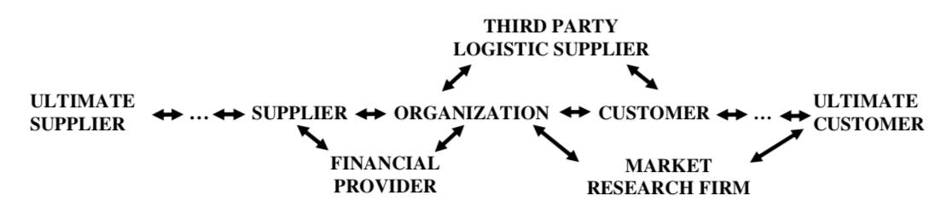Complex**

**2.2: Competitive Strategic approach**

The corporate environment is currently growing more competitive. Managing a company's production value chain includes the management of interconnected value operations. The company's competitive advantage is determined by how it manages its links, which can be achieved through low-cost or differentiated strategies.

Must be in line with the company's goals and strategies

Must be in line with needs of customers

Must be in lined with position of power of company

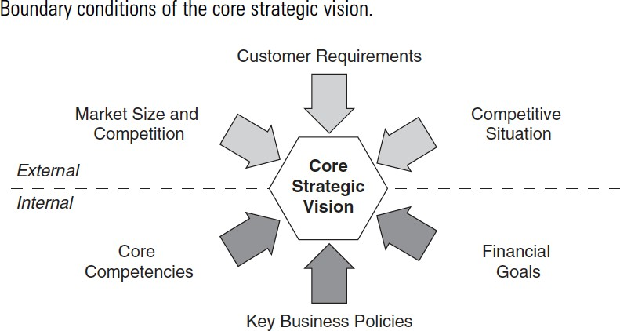

**Figure2.1:   
2.3: The WoolWorth’s Project Refresh**Project Refresh is at the core of Woolworths' strategy, an ideal technique for lowering corporate costs. In the year 1999, Woolworths began Project Refresh, with the following goals (Woolworths, 2003):

1. Create a consumer-driven business model with the goal of improving customer purchasing experiences.
2. Restructure the company to make it more efficient.
3. To keep a competitive advantage, cut costs.
4. Provide the consumer with the finest professional ethics and values
5. to put in place supply chain’s best practices.

**REDESIGNED SYSTEM OF WOOLWORTHS SUPPLY CHAIN** Redesigned Functions And The Number Of Total Distributional stores:   
Woolworths uses a distribution warehouse to connect vendors and retailers. Direct Store Delivery was also handled by Woolworths (DSD). DSD allows vendors to ship products directly from their warehouses to Woolworths stores. As seen in Figure, the Woolworths supply chain structure may be seen through distribution units and DSD.

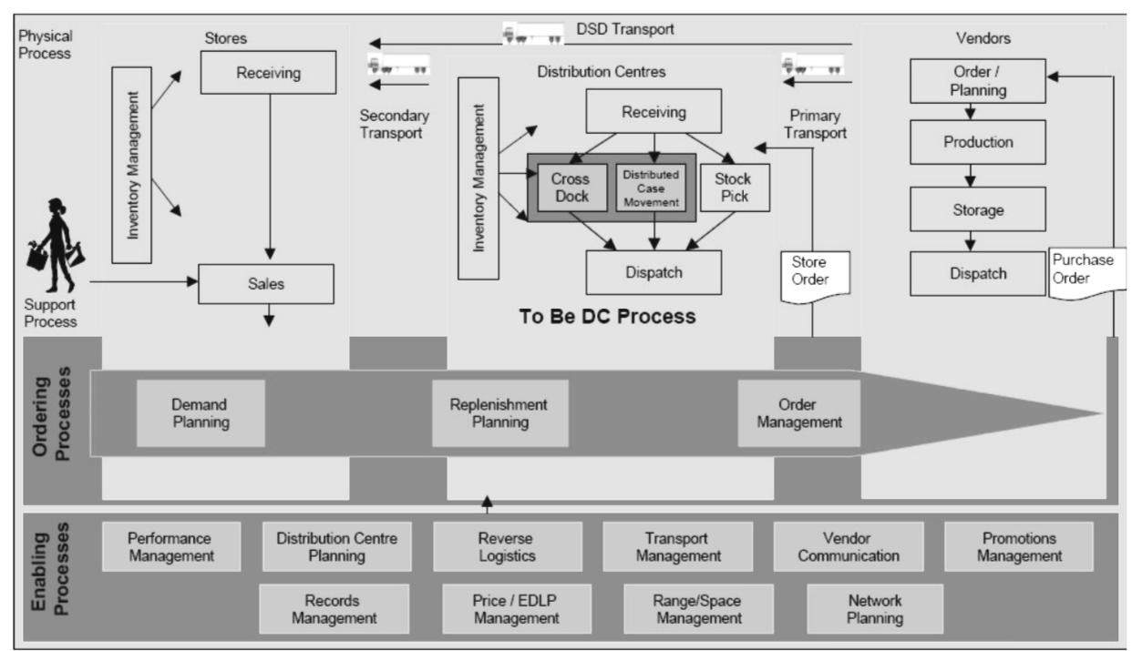

**Figure 3.1**

As part of the project refresh, Woolworths has reduced the number of regional distribution centres (RDC) from 31 to 9 and now controls two national distribution centres (NDC). More distribution centres could lead to excess capacity and greater costs, therefore this is part of Woolworths' Project Refresh strategy to restructure the company to make it more productive and effective. RDCs can be found in Perth, Adelaide, Wyong, Wodonga, Townsville, and Brisbane, among other cities.

**3.2. Transport Management System (TMS)**

Woolworths manages both primary and secondary transportation services to convey stock from vendors to the nearest RDC/NDC, as well as from RDC to shops. Figure 3 depicts the principal and secondary modes of transportation. Woolworths is capable of minimizing transport times and increase safety by operating one's own logistics. It would also save money on transportation and provide you more negotiating power when it comes to inventory expenses.

**3.3 Informational Technology System for assisting efficiently their management of Supply Chain**  
  
Woolworths has developed a comprehensive IT system that is based on the Electronic Data Interchange approach to match its new structure.Now that those critical procedures have been finished, Woolworths plans to save money. Customers, enterprises, and suppliers can all benefit from IT systems that allow them to share critical information, skills, and experiences. The graphic displays the Woolworths supply chain's IT applications for vendors, distribution centres, and shops. Figure depicts the Woolworths IT system:

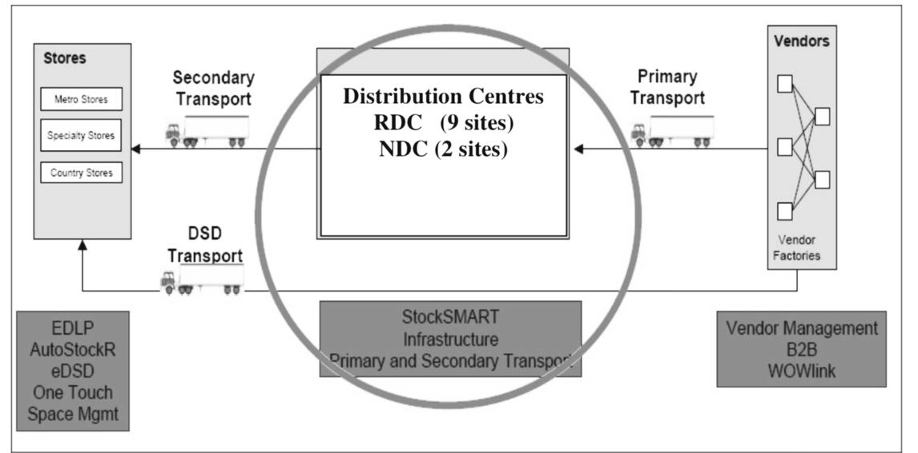

**Figure 3.2**

**WOOLWORTHS WAY OF ALIGNMENT OF SUPPLY CHAIN WITH BUSINESS STRATEGIC APPROACHES AND CUSTOMER REQUIREMENTS**

Woolworths has resurrected its 'Fresh Food People' campaign and deployed various self-labeled items to minimize expenses in the wake of the entry of Aldi and Costco, as well as continuous competition from large competitor Coles.

Woolworth’s strategy for approaching supermarkets' top priorities;

* Give the best value to customers through important supermarket advertisements that saved them over $750 million. The average rate of price deflation was 3.1 percent.
* Fresh market share is growing faster than Grocery, so it's time to improve the offer.

It's also worth mentioning that Woolworths also dropped 2% of its share of the market in recent months to Coles and the Aldi. Stockouts in important categories can occur as frequently as 20% of the time, Leaving some shelves appearing barren and unorganized.

**4.1: Influence and Adaptive**

*A good supply chain strategy is grounded in an understanding of your power and influence relative to customers and suppliers’ - Cohen and Roussel (2005)*

Woolworth's stores account for 39% of Australia's $82 billion food market, having a profit margin of 9.3%, which is among the finest in the world.

At this point, the biggest worry is whether Woolworths is leveraging its market dominance and position by decreasing prices and slashing costs to the detriment of suppliers. Aldi, according to reports, buys only from local suppliers and only imports products from other countries when they are not available locally. Woolworths sources its products from both domestic and foreign vendors

**SYNCHRONIZATIONAL IMPROVEMEMTS**According to Bowersox (2013, p. 47), synchronization is defined as;

**‘Multifirm operational integration across a supply chain is referred to as supply chain synchronization.*’***

As previously stated, Woolworths chooses to improve short-term goals by actively growing margins above improving long-term performance and increasing sales.

As a result, Woolworths' present patterns match Christopher's (2011, p.47) description of a normal distribution network. To 'force' things into its retail stores, Woolworths uses forecasting and scheduling processes.

The apparent absence of communication from Woolworth's major responsibilities to other supplier relationships is a fundamental concern in terms of synchronization..

**RISK/DISADVANTAGES**

Blackurst et al. (2005), Yang and Yang (2010) were cited by Diabat et al. (2012). *‘Supply chain risk may reuslt from unexpected variations in capacity constraints, or from breakdowns, quality problems fires or natural disasters at the supplier end.’*

There are various areas where company could be at risk:

* Risks at the macro levels
* Risks associated with demand management
* Risks associated with managing supply
* Risks associated with goods management
* Risks associated with data management

**6.1 Product And Its Risk in Service Management:**

The amount of inventory that is currently on hand at the retail level are extremely high, as mentioned briefly in the preceding section. The majority of the stock on hand is set aside for special sales or new product lines allotted to a certain retailer.

**6.2** **Risks in Information Managements**

" Errors in anticipating product demand, as well as information sharing inefficiencies, pose a threat to the supply network, and IT system failures," according to the definition. Customers' wants are not forecasted using sales data, which is a major flaw in 'push' supply chains. Instead, as indicated previously in this text, this function is ignored due to a focus on cost efficiency and reduction in order to increase margin.   
**6.2.1: Revenue growth and comparison**Woolworths' overall market capitalization is $46.89 billion Australian dollars, and its total revenue is expected to be around 1.97 billion Australian dollars in 2021, up from prior years.

|  |  |
| --- | --- |
| **Year** | **Net profit in billion Australian Dollars** |
| **2021** | **1.97** |
| **2020** | **1.64** |
| **2019** | **1.81** |
| **2018** | **1.67** |
| **2017** | **1.47** |
| **2016** | **1.52** |
| **Table: 6.1** | |

Coles and Woolworths are two of Australia's leading supermarket retailers. They are both competing for success, and They have a significant number of stores in a number of different towns and cities. So, here's a quick rundown of financial data and comparisons between the two.

|  |  |  |
| --- | --- | --- |
|  | Coles | Woolworths |
| Revenue ($m) | 16583 | 21200 |
| EBIT ($m) | 789 | 1176 |
| EBIT/Revenue (%) | 4.75 | 5.549 |
| Gross margin | 24.72 | 29.11 |
| Sales per square m ($) | 3.29 | 4.89 |
| Total sales (yearly %) | 2.01 | 2.69 |
| Customers satisfaction (100) | 88.49 | 80.5 |
| **Table 6.2:** | | |

As a result, we can see that Woolworths' sales are significantly higher than Coles'. This is really encouraging, and it is clear now that Woolworths is doing well with increased revenue.

**RECOMMENDATIONS**

Supplier unhappiness, high inventory levels in local retail locations, and ineffective communication with key supply chain partners are just a few of the major issues.

* First step is to replace the current hierarchy with a stronger rational. Removing the "Buyers' Market" strategy and replacing it with a "Sellers' Market" approach of Cohen and Roussel's (2005, p.20) Four Criteria to the workplace would result in a more strategic and collaborative environment.
* To choose which things will be sold in stores, merchandising partners with Marketing and Buyers.
* Finance would set the purchasers' spending budgets and hold them accountable for attaining the company's profit margin targets.
* Supply chains and merchandising will work together to set delivery standards based on POS sales trends and individual product turnaround times.
* Stores are responsible for keeping the product's purity and making it available to customers when they need it. To put it another way, the store's job is to make sales, not money.
* Forecasting at the store level should be done based on product turnover and sales rates. Forecasting at the store level will assist in avoiding overstocking and increasing customer in-stock.

|  |  |  |  |  |
| --- | --- | --- | --- | --- |
| **Average Daily Sales** | **Turn Around in**  **Days** | **Shelf Capacity** | **Carton Size** | **Stock OnHand**  **Needed** |
| **2.1** | **21.2** | **12.1** | **11.9** | **4 cartons**  **every 3.5 weeks** |
| **Table 7.1** | | | | |

**CONCLUSION**

Initially, supply chain management requires overseeing a variety of interconnected activities spanning from the procurement of source to the point of a final product to a consumer. As a result, some analysts predict that evaluating and improving current communication might save Woolworths $1 billion in supply costs. Solving an issue by readjusting and replacing it while ignoring what is underpinning this, just serves for prolonging the erosion of trust. The AMR Research ranks Woolworths as the only Australian company in Top twenty five in the year 2005 and next year as well as a struggle and consequences of its performance. It is possible to achieve optimal information utilization with the help of technology, which is the golden key to a successful supply chain. Project Refresh has proven to be a successful in management of strategic approach for Woolworths. To improve and integrate linkages in its distribution network, Woolworths restructured its distribution strategy, aggressively involved its suppliers, and developed an improved information and technology system.. Woolworths has risen to the top of the Australian retail industry thanks to its overhauled supply chain management, which has resulted in significant cost reductions.

# REFERENCES

Battersby, L 2013 ‘Suppliers rate Aldi above Woolworths and Coles’ The Sydney Morning Herald-Business Day, 5th March 2013, viewed 22 October 2014 <http://www.smh.com.au/business/suppliers-rate-aldi-above-woolworths-and-coles->20130305-2fidz.html

Bowersox, D, Closs, D, Cooper, MB and Bowersox, J 2013 ‘Supply Chain Logistics Management’ Fourth Edition, McGraw-Hill Companies, Inc.,

Blackhurst, J, Craighead, CW, Elkins, D and Handfield, RB 2005 ‘An empirically derived agenda of critical research issues for managing supply-chain disruptions’ International Journal of Production Research, Volume 43 Issue 19, 4067–4081.

Cohen, S and Roussel, J 2005 ‘Strategic Supply Chain Management – The 5 Disciplines for Top Performance’, McGraw-Hill Companies Inc.,

Diabat, A, Govindan, K and Panicker, V 2012 ‘Supply chain risk management and its mitigation in a food industry’ International Journal of Production Research Vol. 50 No.11, 3039-3050

Ferrari, B 2014 ‘Gartner Announces Top Ten Best Supply Chains in Asia Pacific Region’, viewed 22 October 2014,

<http://www.theferrarigroup.com/supply-chain-matters/2014/09/08/gartner-announces->top-ten-best-supply-chains-in-asia-pacific-region/

Kumar, S 2008 ‘A study of the supermarket industry and its growing logistics capabilities’, International Journal of Retail & Distribution Management, Vol. 36 No. 3, Emerald Group Publishing Limited

Lee, H 2004 ‘The Triple-A Supply Chain’, Harvard Business Review, HBR OnPoint 8096, 102-12

Penney, JC n.d., ‘James Cash Penney Quotes’, viewed 22 October 2014, <http://www.brainyquotes.com/quotes/authors/j/james_cash_penney.html>

Yang, B and Yang, Y 2010 ‘Postponement in supply chain risk management: a complexity perspective’, International Journal of Production Research, Volume 48 Issue 7, 1901–1912

Billo, R.E., Porter, J.D., Mazumdar, M. and Brown, S.J. (2003). Impact of bar code print quality on the performance of high-speed sortation systems. *Journal of Manufacturing Systems*, 2003, 22(4):317-326.

Cottrill, K. (1997). The supply chain of the future. *Distribution*, Oct, 96(11): 52.

Ellram, L. and Cooper, M. (1993). Characteristics of supply chain management and the implications for purchasing and logistics strategy. International Journal of Logistics Management, 4(2): 1-10.

Handfield, R.B. and Nichols, E.L.Jr. (1999). *Introduction to Supply Chain Management*, Prentice Hall, Upper Saddle River, N.J.

Lambert, D.M. and Knemeyer, A. M. (2004). We’re in this together. *Harvard Business Review*, Dec, 82 (12): 114-122.

Lambert, D.M. and Cooper, M.C. (2000). Issues in supply chain management. *Industrial Marketing Management*, 29: 65-83.

Lambert, D.M., Cooper, M.C. and Pagh, J.D. (1998). Supply chain management: implementation issues and research opportunities. *International Journal of Logistics Management*, 9(2): 1-19.  
Porter, M. E. (1985). *Competitive Advantage: Creating and Sustaining Superior Performance*, New York Free Press, London.

Porter, M.E. and Millar, V.E. (1985). How information gives you competitive advantage. *Harvard Business Review*, Jul/Aug, 63(4):149-160.

Porter, M.E. (1985). Technology and competitive advantage. *Journal of Business Strategy,* Winter, 5(3): 60-68.